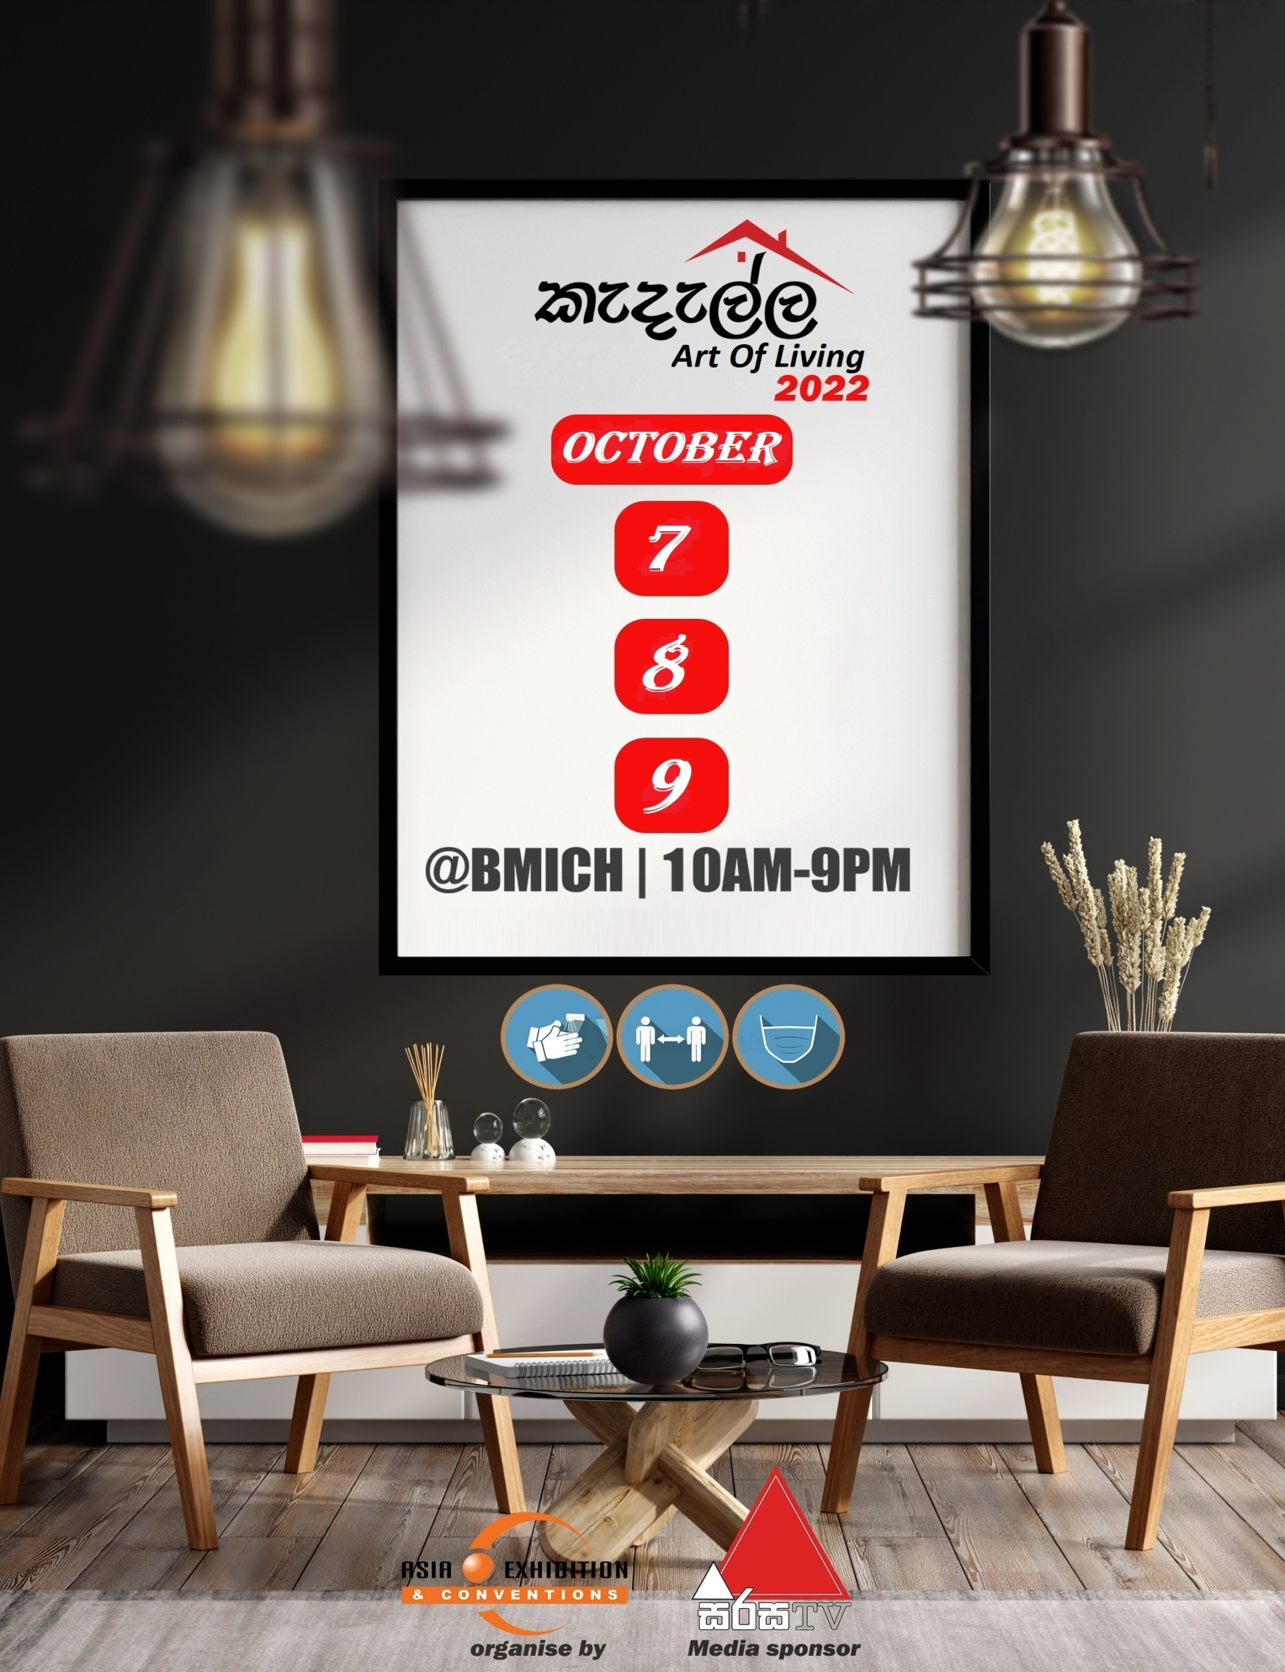

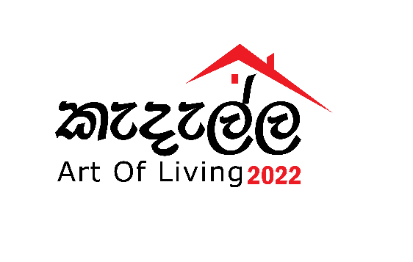

KEDELLA ART OF LIVING 2022

Dear Sir / Madam,

We are pleased to introduce “Kedella Art Of Living 2022" organized by Asia Exhibitions & Conventions (Pvt) Ltd in association with Electronic Media Partners & Wijeya News papers Ltd, it will be held from 7th – 9th October 2022 scheduled from 10.00 a.m. to 9.00 p.m. at the Sirimavo Bandaranaike Memorial Exhibition Centre (BMICH - Colombo).
“Kedella Art Of Living 2022” exhibition will consist of approximately over 200 stalls to attract more visitors from every occupation. Product profile of Art of Living consists of Household appliances, Home decorations, Homes & real estates, Landscaping, Furniture, Tiles & Granite traders, Bathroom fittings, Kitchen were & Electrical goods, Paints, Wall design traders, Ceiling decorators, Lighting, Home Drapers, Banks & Insurance Co. etc...
This is the event where you can promote your business at highly exclusive platform to absorb the potential segments in these sectors to uplift your professional business & services in Sri Lanka. Apart from that, this exhibition will be a good advantage & helpful for homemakers and other buying people to choose their requirements at a competitive rate.
We take great pleasure in inviting your esteemed organization to be a part of this event being a sponsor / stallholder of “Kedella Art Of Living 2022” and we look forward to your early conformation in this regard.
For more information/clarification, please feel free to contact the undersigned on 0719 997712.(Venura)

Thanking You,
Yours Sincerely,

Venura Wijerathna
Senior Marketing Manager

